Now Showing:

Child's Name
5th Birthday
Celebration
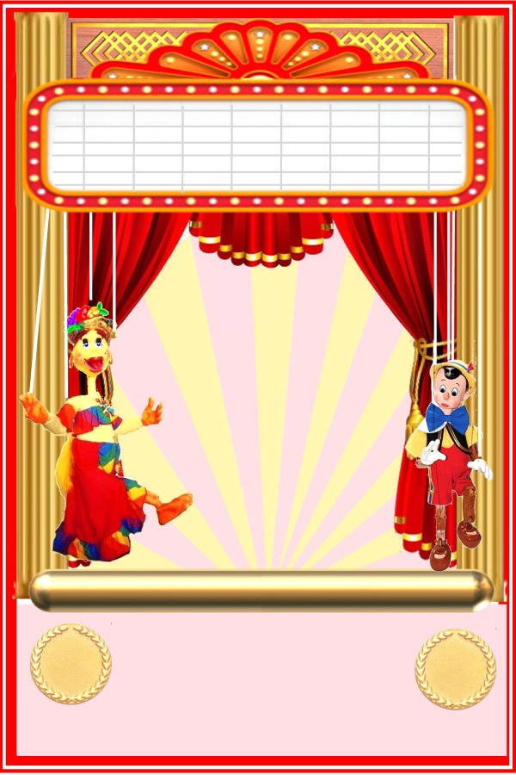
5th
The Last Name Residence
1234 Street Name
Any City, CA 90000
RSVP Cathy Smith 555-555-1212
5th
Saturday June 16th
1-4 p.m.
Puppet Show Starts
2:00 p.m.

Don't Miss the Show!

